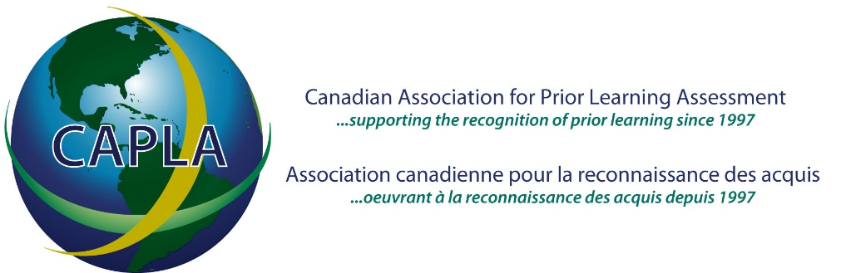

October 3, 2025

Dear CAPLA Members and other RPL stakeholders:

This letter is a formal notice that CAPLA will be holding elections for its Board of Directors on November 26, 2025. We invite you to consider joining the Board or nominating a colleague. The election will be held in conjunction with our virtual Annual General Meeting, at 12:00 pm Eastern Time. The AGM will be held via Zoom, and registration to attend will be done via Eventbrite; please click here to register. There is no cost to attend the AGM.

Founded in 1994, CAPLA was officially incorporated in June of 1997 as a non-profit corporation for the advancement of the recognition of prior learning (RPL) in Canada. Its mission is to work toward the development of human resource and educational services which are flexible and responsive to the changing needs and circumstances of adults. CAPLA advocates for the formal acknowledgement of lifelong learning experiences so that the acquisition of knowledge, skills, abilities and competencies is valued and recognized in Canada.

Within CAPLA’s Organizational Bylaws, Article 5, section 5.2 states that the Board will not be less than seven (7) nor more than twenty (20) members; section 5.3 provides that the term of a Board member is three (3) years, twice renewable. Based on the maximum number of Board members allowed, there will be four (4) spots available on the Board in 2025-26.

The following criteria have been established to provide clear guidelines for those considering becoming or nominating Board members.

A Board member must be able to demonstrate:
- advocacy for adult lifelong learning with a commitment to access, equity, innovation and education and training reform
- a sound knowledge of RPL and adult learning principles
- commitment to and interest in the advancement of recognition of prior learning (RPL) at the local, provincial/territorial, federal, and/or international level
- capacity to underwrite costs associated with teleconferences, virtual professional development activities, and future face-to-face meetings
- active participation in yearly sponsorship and fundraising activities among your networks and within your region
- a willingness to volunteer significant time and effort to help maintain and expand CAPLA and its services
The time commitment for a Board member’s participation in regular Board meetings is estimated at 20 hours per year. Board members who take on an Executive/ Management role can expect to commit additional hours to CAPLA. Please email info@capla.ca for more information.
Nominators and nominees must be CAPLA members in good standing. Members in good standing have paid their memberships fees in full by 12:00 pm of the day preceding the Annual General Meeting (AGM). Members in good standing are eligible to vote at the AGM. Institutional members are entitled to one vote. Those who purchase a membership after 12:00 pm on November 26, 2025 will be granted voting privileges only and cannot be nominated as a potential Board member for 2025-26. To become a member, click on this link.

Below is the two-part CAPLA Board of Directors nomination form, which consists of a nomination statement and an acceptance of nomination statement. Please review this information and submit it before November 12, 2025 to the CAPLA Board of Directors at info@capla.ca. In addition to the acceptance of the nomination, a brief profile of the nominee is required.

Last minute nominations may also be submitted up to 12:00 pm EST on November 25, 2025, the day preceding the virtual AGM. This method of nomination requires the printed name, organization and signature of twenty members in good standing who are supporting the nomination. Names of all nominators will be validated by the CAPLA Board of Directors. In the interests of planning and to ensure all nominations are received, we would suggest sending all forms by the November 12 deadline.

Also below is a PROXY FORM for voting at the AGM. If you are unable to attend the meeting, please complete the form and select one of the existing Board members listed or another CAPLA member of your choice who will be attending the AGM to vote on your behalf. Please send the completed forms to the CAPLA Board of Directors at info@capla.ca. This step will give you a voice in the decisions that are made and will help us to achieve quorum.

Please email the Proxy and/or Nominations forms to the CAPLA Board of Directors at info@capla.ca on or before November 12, 2025.

Please note that if you have not received acknowledgement of your emailed Proxy or Nomination form within 48 hours, or have additional questions, you should follow-up with the CAPLA Board of Directors by email.

Click here to register for the AGM via Eventbrite.

TO THE CAPLA BOARD OF DIRECTORS

CAPLA NOMINATION FORM (2025)

I, __________________________, being a member of CAPLA in good standing, do hereby nominate __________________, a member of CAPLA in good standing, for election to the Board of Directors. Attached is a brief profile of my nominee.

Date ___________________________ Signed ___________________________

Please e-mail this completed form to info@capla.ca

TO THE CAPLA BOARD OF DIRECTORS

CAPLA NOMINATION FORM (2025)

ACCEPTANCE OF NOMINATION

I accept my nomination by ________________________ and am prepared to allow my name to stand for election to the Board of Directors.

Date ___________________________ Signed ___________________________

Please e-mail this completed form to info@capla.ca

TO THE CAPLA BOARD OF DIRECTORS

CAPLA PROXY VOTING FORM (2025)

As a member of CAPLA, I hereby appoint ____________________________ as my proxy to attend and act at the Annual General Meeting of the members of the said Corporation to be held on November 26, 2025 and at any adjournment or adjournments thereof in the same manner, to the same extent and with the same power as if I were present at the Annual General Meeting or such adjournment or adjournments thereof.

Dated the ______ day of _______________, 2025

_______________________
Signature of Voting Member

Please e-mail this completed form to info@capla.ca

Current CAPLA Board Members:

Gary McNeely (MB) | 2022-2025: Nominated to renew 2025-2028
Susan Forseille (BC) | 2022-2025: Nominated to renew 2025-2028
Paula Romanow (NS) | 2022-2025: Nominated to renew 2025-2028
Amanda Morrissey (NS) | 2022-2025: Not renewing
Mackenzie Bartlett (NB) | 2022-2025: Not renewing
Andy Brown (QC) | 2023-2026
Judy Tavares (ON) | 2023-2026
Don Presant (MB) | 2023-2026
Michelle Chisholm (NB) | 2023-2026
Patrick Reinartz (NB) | 2023-2026
Erin Mandel-Shorser (ON) | 2024-2027
Doug Gray (BC) | 2024-2027
Melissa Josey (PEI) | 2024-2027
Liz Nicholas (ON) | 2024-2027
Tenielle McLeod (SK) | 2024-2027
Jeremy McQuigge (ON) | 2024-2027
Lindsay Guitard (NS) | 2024-2027
Suzanne Wassef (QC) | 2024-2027: Resigned

